7/9/2015

**README – State Catchment Map Package Zipfiles**

**LOCATION:** <https://edg.epa.gov/data/PUBLIC/OW/STATECATCHMENTMAPSGISAPPLICATIONS>

**PURPOSE:** To provide a map project aimed at those wanting to learn more about NHDPlus catchments and how they will be used in the implementation of the new 303(d) Program performance measures. These map packages include: state/territory boundaries, National Hydrography Dataset Plus (NHDPlus) NHD snapshot, and NHDPlus catchments (more information about these layers is provided below). The geospatial information in this map package can serve as a starting point for adding other features that are of interest to a state, which may include: state priorities defined under the 303(d) Program Vision, political boundaries, and HUC12s.

**SOFTWARE REQUIREMENTS:**

* ArcGIS 10.x
* Software to open zipfiles (such as WinZip)

**LAYER DESCRIPTIONS:**

1. States/Territories - Detailed boundaries for US States and Territories

2. NHDPlus_NP21/NHDSnapshot_Flow_Direction_NP21_Labeled - Map service containing GIS data from the EPA Office of Water NHDPlus v2.1 data set, which includes: Network Flowlines, Non-Network Flowlines, and Waterbodies (symbolized by Feature Type). This service also provides a sub-layer that

uses arrowhead symbols to show the downstream flow-direction for each flowline in the network and, by association, the catchment for each flowline. The features in this service are scale-dependent, meaning that the map must be zoomed in to 1:100,000 or closer for the features to appear. The labels for the individual layers can be turned on/off by right-clicking the applicable layer and clicking 'show labels'.

3. Catchments – A snapshot of the NHDPlus V2.1 Catchments that have been clipped to the detailed state boundaries.

**GETTING STARTED:** The zip files (located in <https://edg.epa.gov/data/PUBLIC/OW/STATECATCHMENTMAPSGISAPPLICATIONS>) each contain a state-specific ESRI map package (.mpk) and a copy of this readme.txt file. Follow these steps:

• Download the zip file that includes the name of the state of interest. For example, for Hawaii, download "State Catchment Map - Hawaii.zip".

• Unzip using WinZip (<http://www.winzip.com/win/en/landing/prodpagewz.html>) or a similar decompression software. With WinZip, one can open a Zip file by double clicking it in the Explorer window or by starting WinZip and choosing "Unzip or install from an existing Zip file" in the WinZip Wizard. The WinZip Wizard will guide the user through the process of unzipping the file.

**METADATA:**

The ESRI Map Packages contain metadata files for the following layers:

* 'States/Territories' - 'metadata.v10.xml'

• 'Catchments' - 'NHDPlusV2_metadata.xml'

Metadata for 'NHDPlus_NP21/NHDSnapshot_Flow_Direction_NP21_Labeled' is located at: [http://www.horizon-systems.com/nhdplus/NHDPlusV2_home.php](http://www.horizon-systems.com/nhdplus/NHDPlusV2_home.php%20) (NHDPlus documentation)

**WORKING WITH THE MAP PACKAGE:**

• Browse to the location where the map package ([state name].mpk) was unzipped and open the map by double-clicking the map package. An ArcMap project (.mxd) will open, zoomed in to the applicable state.

• The state boundary and NHDPlus catchments for the state should be visible at all scales.

• The layers within the NHDPlus_NP21/NHDSnapshot_Flow_Direction_NP21_Labeled - Map service will become visible once the map is zoomed to 1:100,000 or closer. The map is fully editable (symbology, layer names, etc.)

• Users may add additional layers of interest by adding shapefiles, geodatabase feature classes, etc.

• For more information about ESRI Map Packages, please visit: [http://resources.arcgis.com/en/help/main/10.2/index.html#//006600000403000000](http://resources.arcgis.com/en/help/main/10.2/index.html%23/006600000403000000) and

[http://resources.arcgis.com/en/help/main/10.2/index.html#/Package_Map/0017000000q5000000/](http://resources.arcgis.com/en/help/main/10.2/index.html%23/Package_Map/0017000000q5000000/)

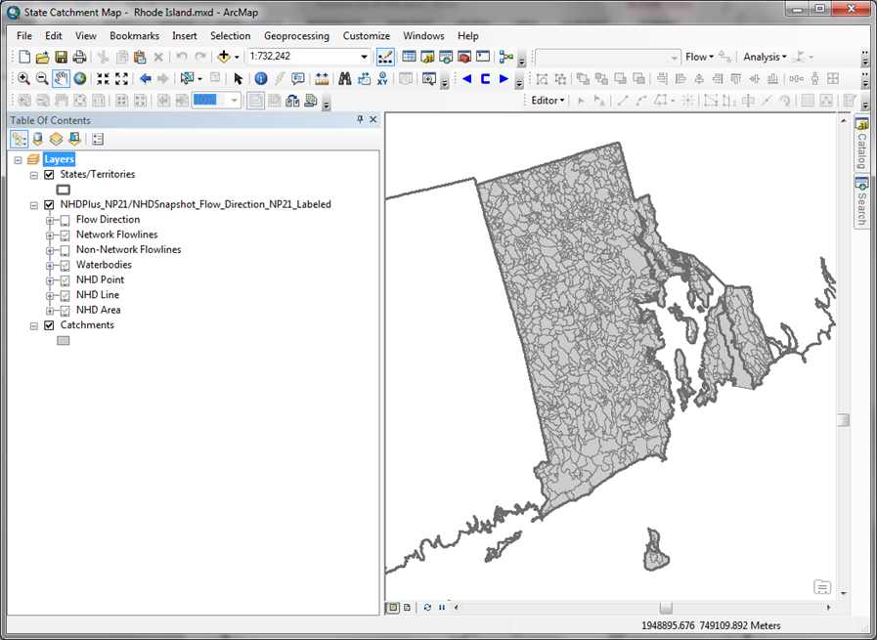

Upon opening this map package, the file geodatabases containing the feature classes referenced in the map, will be copied to a local directory. To determine the location of this directory, click on 'List by Source' button in the ArcMap Table of Contents. It is helpful to know where the data exists in order to reference it for further use.

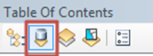

**PRINTABLE POSTER FILES:**

In addition to the state catchment map packages, posters which depict the catchments for each state, individually, can be downloaded from <https://edg.epa.gov/data/PUBLIC/OW/STATECATCHMENTMAPSSTATICPOSTERS>. These are images of map layouts that can be printed as large posters.

**CONTACTS:**

Seth Mann (Innovate, Inc.) – [mann.seth@epa.gov](mailto:mann.seth@epa.gov)

Shera Reems (US EPA) – [reems.shera@epa.gov](mailto:reems.shera@epa.gov)

Dwight Atkinson (US EPA) – [atkinson.dwight@epa.gov](mailto:atkinson.dwight@epa.gov)